|  |  |
| --- | --- |
| **Total Marks:** | **7.5** |
| **Obtained Marks:** |  |

**DATA STRUCTURE**

**AND**

**ALGORITHM**

**Lab Report # 12**

**Submitted To: Mam Tehreem**

**_____________________________________________________________________________________________________________________________________________________________________________________________________________________________________**

**Submitted By**: **Hammad Qureshi**  .

**Reg. Numbers: 2112114**

**______________________________________________________________________________________________________________________________________________________________________________________________________________________________________**

**Question no 1:**

**Write a program to find the node 1 using BFS approach  
  
Write a program to find the node 1 using DFS approach**

**Code:**

|  |
| --- |
| **Bfs Code**  #include <bits/stdc++.h>  using namespace std;    // This class represents a directed graph using  // adjacency list representation  class Graph {  int V; // No. of vertices    // Pointer to an array containing adjacency  // lists  vector<list<int> > adj;    public:  Graph(int V); // Constructor    // function to add an edge to graph  void addEdge(int v, int w);    // prints BFS traversal from a given source s  void BFS(int s);  };    Graph::Graph(int V)  {  this->V = V;  adj.resize(V);  }    void Graph::addEdge(int v, int w)  {  adj[v].push_back(w); // Add w to v’s list.  }    void Graph::BFS(int s)  {  // Mark all the vertices as not visited  vector<bool> visited;  visited.resize(V, false);    // Create a queue for BFS  list<int> queue;    // Mark the current node as visited and enqueue it  visited[s] = true;  queue.push_back(s);    while (!queue.empty()) {  // Dequeue a vertex from queue and print it  s = queue.front();  cout << s << " ";  queue.pop_front();    // Get all adjacent vertices of the dequeued  // vertex s. If a adjacent has not been visited,  // then mark it visited and enqueue it  for (auto adjecent : adj[s]) {  if (!visited[adjecent]) {  visited[adjecent] = true;  queue.push_back(adjecent);  }  }  }  }    // Driver program to test methods of graph class  int main()  {  // Create a graph given in the above diagram  Graph g(4);  g.addEdge(0, 1);  g.addEdge(0, 2);  g.addEdge(1, 2);  g.addEdge(2, 0);  g.addEdge(2, 3);  g.addEdge(3, 3);    cout << "Following is Breadth First Traversal "  << "(starting from vertex 0) \n";  g.BFS(0);    return 0;  }  **Dfs Code**  #include <iostream>  #define MAX 5  const int stackSize = MAX;  using namespace std;  class Stack {  private:  int top;  int arr[stackSize];  public:  Stack() {  top = -1;  }  void push(int value) {  if (top + 1 >= stackSize) {  cout << "Stack Overflow" << endl;  } else {  top = top + 1;  arr[top] = value;  }  }  int pop() {  int stackPopVal;  if (top <= -1) {  cout << "Stack underflow" << endl;  } else {  stackPopVal = arr[top];  top--;  }  return stackPopVal;  }    bool isStachEmpty() {  if (top == -1) {  return true;  } else {  return false;  }  }  int peek() {  return arr[top];  }  void display() {  if (top >= 0) {  cout << "Stack elements are:";  for (int i = top; i >= 0; i--)  cout << arr[i] << " ";  cout << endl;  } else  cout << "Stack is empty";  }  };  int adjMatrix[MAX][MAX];  struct Vertex {  char label;  bool visited;  };  class DepthFirstSearch{  public:  struct Vertex* lstVertices[MAX];  int vertexCount = 0;  DepthFirstSearch() {  int i,j;  for(i = 0; i< MAX; i++) {  for(j = 0; j< MAX; j++) {  adjMatrix[i][j] = 0;  }  }  }  void addVertex(char label) {  Vertex *vertex = new Vertex;  vertex->label = label;  vertex->visited = false;  lstVertices[vertexCount++] = vertex;  }  void addEdge(int edgeStart,int edgeEnd) {  adjMatrix[edgeStart][edgeEnd] = 1;  adjMatrix[edgeEnd][edgeStart] = 1;  }  //display the vertex  void displayVertex(int vertexIndex) {  cout<<lstVertices[vertexIndex]->label<<" ";  }  int getAdjUnvisitedVertex(int vertexIndex) {  int i;  for(i = 0; i<vertexCount; i++) {  if(adjMatrix[vertexIndex][i] == 1 && lstVertices[i]->visited == false)  return i;  }  return -1;  }  void DFS(){  Stack objStack;  lstVertices[0]->visited = true;  displayVertex(0);  objStack.push(0);    while(!objStack.isStachEmpty()){  int unvisitedVertexIndex = getAdjUnvisitedVertex(objStack.peek());    if(unvisitedVertexIndex == -1){  objStack.pop();  }else{  lstVertices[unvisitedVertexIndex]->visited = true;  displayVertex(unvisitedVertexIndex);  objStack.push(unvisitedVertexIndex);  }    }    }    };  int main() {  DepthFirstSearch obj;  obj.addVertex('S'); // 0  obj.addVertex('A'); // 1  obj.addVertex('B'); // 2  obj.addVertex('C'); // 3  obj.addVertex('D'); // 4  obj.addEdge(0, 1); //S - A  obj.addEdge(0, 2); // S - B  obj.addEdge(0, 3); // S - C  obj.addEdge(1, 4); // A - D  obj.addEdge(2, 4); // B - D  obj.addEdge(3, 4); // C - D  cout<<"Started with index S "<<endl;  obj.DFS();  return 0;  } |

**CONSOLE SCREEN:**

**Bfs**

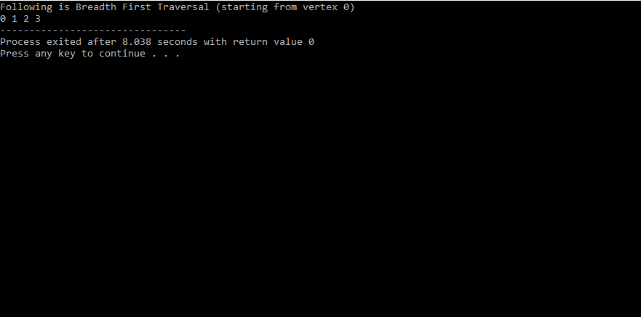

**Dfs**

